Stored Procedures
-----------------------------------------------------------------------------------
Generate_EXAMRandom_SP
This procedure automatically generates an exam for a specific instructor and course by randomly selecting a set number of questions of each type: True/False (TF), Multiple Choice (MCQ), and Text.
1-Checks if the question pool contains enough questions of each type for the specified course. If not, it prints an error and exits.
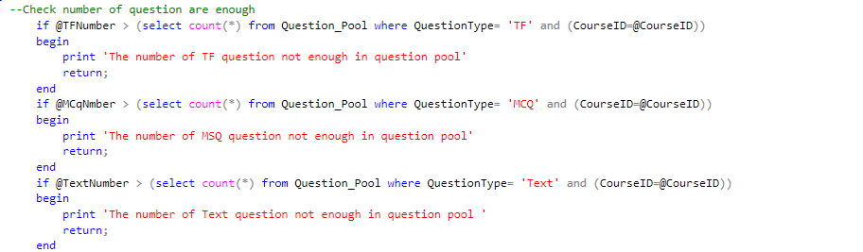
2-check instructor tech this course If not, it prints an error and exits.
3-Starts a transaction to ensure all steps are completed successfully or rolled back if something fails.
4- Adds a new exam to the Exam table with basic details (type, duration, time, course, instructor).
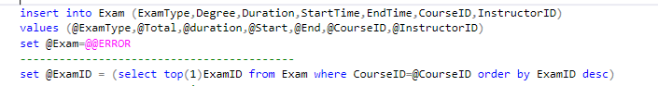

5- Insert Random Questions For each question type (TF, MCQ, Text), it randomly selects the requested number of questions using ORDER BY NEWID() and inserts them into Instructor_Question_Exam.
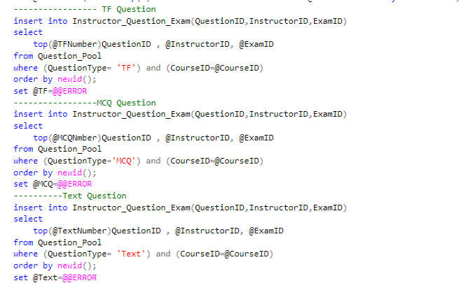
6- Calculate Total Degree and get the max degree of course

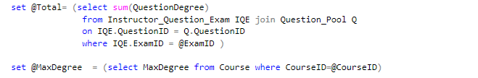

7-If the total degree exceeds the course’s maximum, it rolls back the transaction and exits.
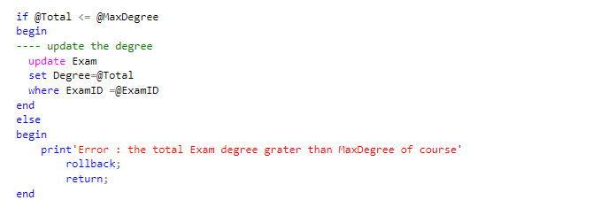
8-If all inserts were successful (@@ERROR = 0), it commits the transaction and prints “Exam done.” Otherwise, it rolls back and prints an error.
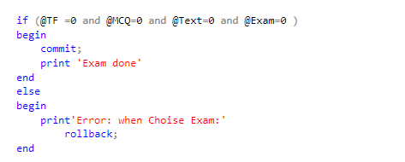

Get_Exam_ForStudent (@ExamID INT)
Returns all questions for a given exam including type, degree, and possible options if the question is MCQ.
This allows the student to view the exam structure.
It only requires the exam ID as input.

Add_All_StudentAnswers (@StudentID INT, @ExamID INT, @Answers StudentAnswersType READONLY)
Saves all the student’s answers for a specific exam in one batch insert.
First, it checks if the exam belongs to the student’s course/track.
If valid, it stores each answer linked with the student and exam.

Correct_Auto (@ExamID INT)
Automatically grades MCQ and True/False questions by comparing student answers with the correct answers.
Text questions are skipped (kept NULL for manual correction).
Returns a message showing how many answers were corrected.

Get_UncorrectedQuestions (@ExamID INT)
Retrieves all questions in the exam that still have no grade (uncorrected).
These are usually text-based answers waiting for manual review.
Useful for instructors to see pending corrections.

Review_Student_TextAnswers (@ExamID INT, @StudentID INT)
Shows a student’s text answers side by side with the model answers.
It tries to check if the answer contains the model answer → “Valid” or “Not Valid”.
Helps the instructor quickly identify matching or incomplete answers.

Correct_AllTextAnswers (@ExamID INT, @StudentID INT, @Answers StudentAnswersTable READONLY)
Lets the instructor manually assign marks for text questions.
Includes validation so the mark can’t exceed the max allowed or be negative.
Updates student’s result once grading is done.

Update_UserIN_OR_ST_SP
This stored procedure, named Update_UserIN_OR_ST_SP, is designed to update a user's information in the Users table based on a given UserID. It accepts six parameters: the user's ID, name, address, birth date, email, and phone number. Inside the procedure TRY ..CATCH to handle error
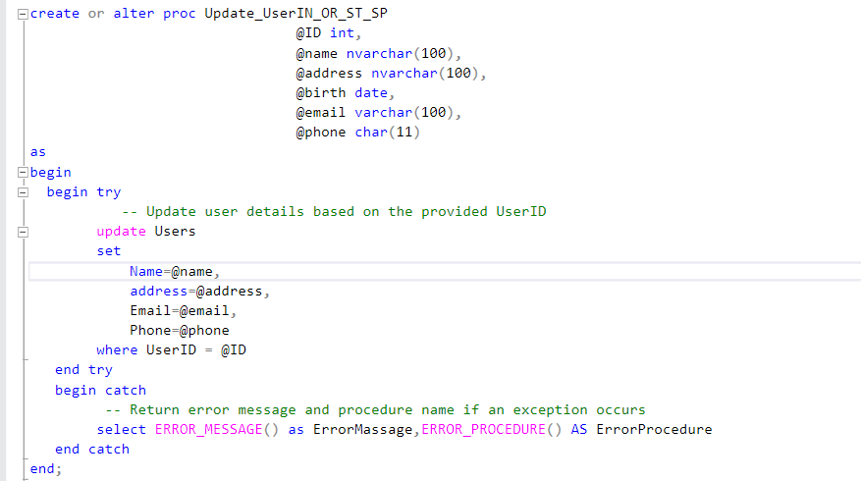
Update_Branch_Manager_SP
Update_Branch_Manager_SP :This procedure updates the manager of a specific branch. It takes two inputs: the branch ID (@ID) and the new manager's ID (@ManagerID). Inside a TRY...CATCH block, it runs an UPDATE command to set the ManagerID for the branch that matches the given BranchID. If something goes wrong during the update, the CATCH block will return the error message and the name of the procedure where the error occurred. This helps with debugging and tracking issues safely
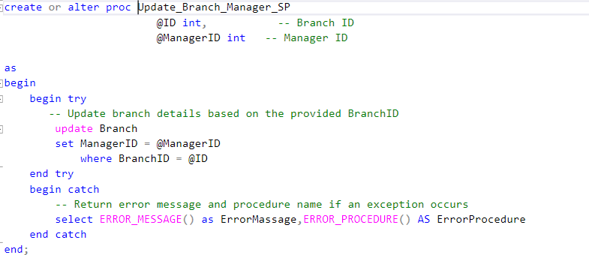

Update_Track_Course_SP
Update_Track_Course_SP : This procedure manages the relationship between a track and a course. It takes three inputs: the track ID (@TrackID), the course ID (@CourseID), and an action option (@option) which should be either 'add' or 'delete'.
If the option is ‘add’, the procedure first checks if the course exists in the Course table. If it does, it inserts a new record into the Track_Course table to link the course to the track. If the course doesn’t exist, it prints a message asking to add the course first.
- If the option is ‘delete’, it removes the course from the Track_Course table based on the given CourseID.
- If the option is anything else, it prints a message asking the user to enter a valid option (add or delete).
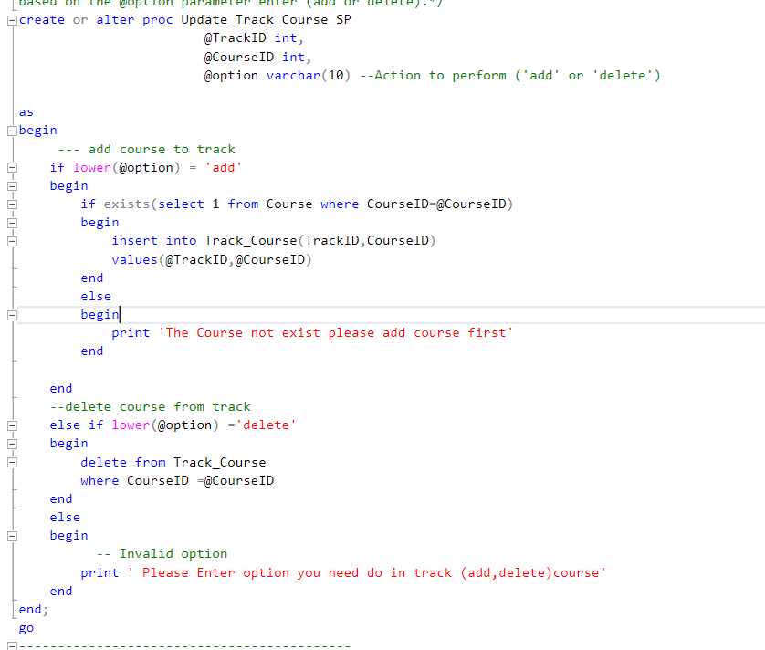

Update_Department_Track_SP
Update_Department_Track_SP: This procedure is used to either add or delete a track in the Track table based on the action specified by the @option parameter. It accepts a table-valued parameter @TrackData of type TrackTableType, which contains one or more rows with TrackID, DepartmentID, and track name (Tname).
- If @option is 'add', the procedure inserts all rows from @TrackData into the Track table.
- If @option is anything else (assumed to be 'delete'), it deletes the track whose TrackID matches the one in @TrackData
- TRY …CATCH Handle error
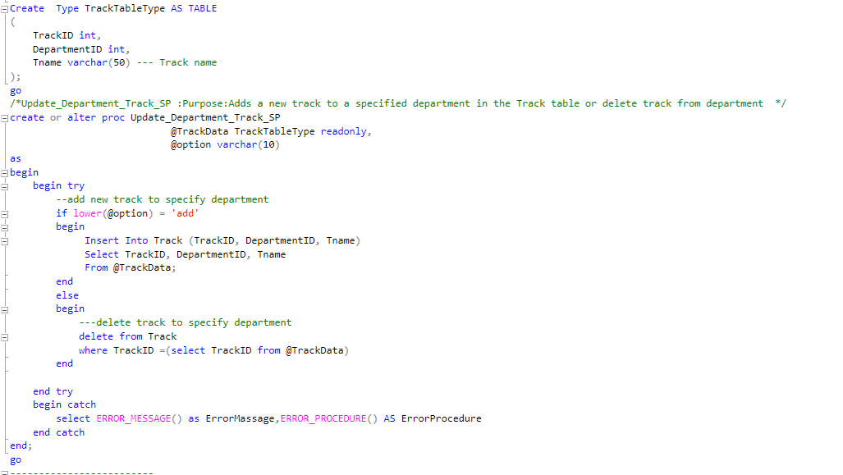
-----------------------------------------
Update_Course_SP
Update_Course_SP:This procedure updates the details of a specific course in the Course table. It takes five inputs: the course ID (@ID), course name (@Name), description (@Description), maximum degree (@Max), and minimum degree (@Min). Inside a TRY...CATCH to handle error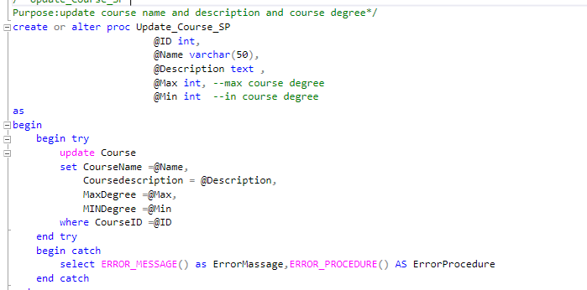
----------------------------------------------------

Update_ExamTime_SP
Update_ExamTime_SP:This procedure updates the timing details of a specific exam. It takes four inputs: the exam ID (@ID), the duration of the exam (@duration), the start time (@start), and the end time (@end). 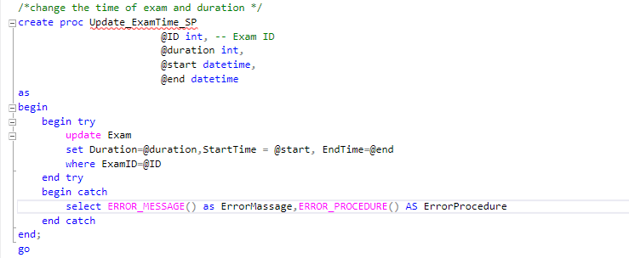
---------------------------------------------

QuestionCorrectAnswer_SP
QuestionCorrectAnswer_SP:This procedure retrieves the correct answer status for a specific question. It takes one input: the question ID (@QID). Inside a TRY...CATCH block, it performs a SELECT query that joins the Question_Pool table with the Answer_MCQ table using the QuestionID. It returns the question text and whether the answer is correct (IsCorrect). If any error occurs during execution, the CATCH block returns the error message and the name of the procedure where the error happened.
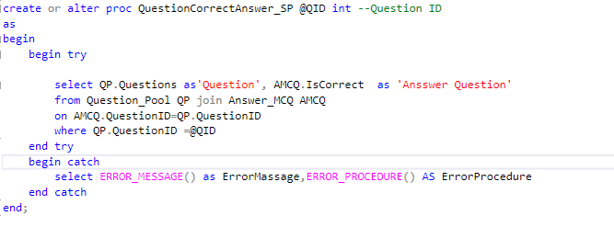
--------------------------------------------------------

GetStudentAnswer_SP
GetStudentAnswer_SP:This procedure retrieves the answers submitted by a specific student for a specific exam. It takes two inputs: the student’s ID () and the exam ID (). Inside a block, it performs a query that joins three tables:
• to get the questions assigned to the exam
• to get the actual question text
• to get the student’s submitted answers
The result shows each question and the corresponding answer given by the student. The clause ensures that only answers from the specified student and exam are returned.
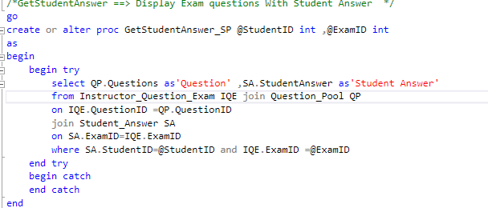
-----------------------------------------------

Generate The Exam Manually
Generate_ExamManually_SP:This procedure is designed to manually create an exam for a specific instructor and course. It takes several inputs: instructor ID, course ID, exam type, duration, start and end time, and a comma-separated list of question IDs (@QID).

1-first Checks if the instructor is assigned to the given course. If not, it prints an error and exits.
2-Creates a temporary table #QID and fills it with the question IDs from the input string using STRING_SPLIT.
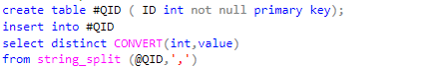
3- Checks if all question IDs exist in the Question_Pool. If any are missing, it prints their IDs and exits.
Declare @missingID to save the id not exist in question pool
And using string_agg to Concatenate the id
Then check if @missingID saved any id or not
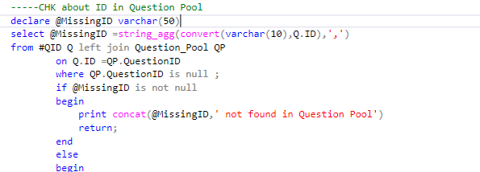
4-Ensures all selected questions belong to the specified course. If not, it prints the invalid IDs and exits. 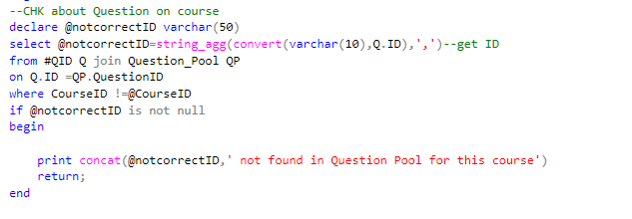
5-Begin Transaction Starts a transaction to safely insert the exam and its questions.
6-Insert Exam Record Adds a new row to the Exam table with the provided details.
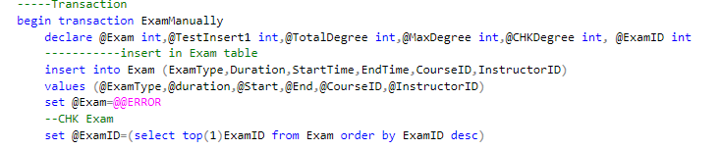
7-insert data into Instructor_Question_Exam
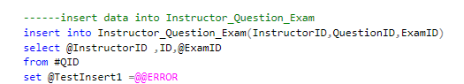
8-Calculate Total Degree Sums the degrees of all selected questions and maxdegree of course then Compares the total degree with the course’s maximum allowed degree. If it exceeds, the transaction is rolled back
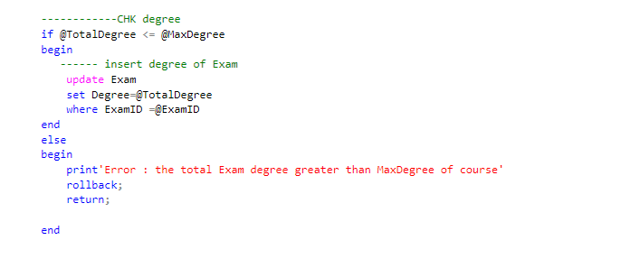
9-If everything is successful, it commits the transaction and prints “Exam done.” Otherwise, it rolls back and prints an error.
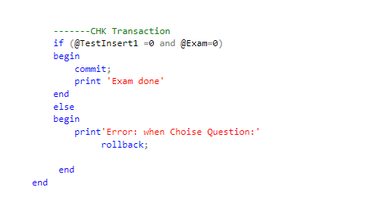

--Insert Sp---
-------------------------
--1- Insert Student Sp : Stored Procedure for Inserting Student Records
-------------------------------------------------------
-- => Create type table to user
-- => Create type table to student
-- => use these types table in SP to insert into
-- => create Sp : Insert_Students_SP
-- => this sp take two parms UserTableType and StudentTableType
----------------------------------------------------------------------------------------------------------------------
=>Input Parameters
-----------------------
@UsersData (UserTableType) → Holds general user details (Name, Address, BirthDate, Email, Gender, Phone, UserType, Password).

@StudentsData (StudentTableType) → Holds student-specific details (TrackID, IntakeID).
-----------------
=> Process Flow
----------------
1- Inserts user information into the Users table, ensuring only records with UserType = 'S' (students) are included.
2- Retrieves the latest generated UserID for the newly inserted student.
3- Inserts the related student record into the Student table, linking it with the retrieved UserID and additional academic details (TrackID, IntakeID).
4- Uses TRY...CATCH for error handling to capture and return error messages in case of failure.
*******************************************************************************************************************************
2. Insert_Instructors_SP : Stored Procedure for Inserting Instructor Records
-----------------------------------------------------------------------------
-- => Create type table to user
-- => Create type table to Instractor
-- => use these types table in SP to insert into
-- => create Sp : Insert_Instructors_SP
-- => this sp take two parms UserTableType and InstructorTableType
--------------------------------------------------------------------------------------------------
=> Input Parameters
--------------------------------
@UsersData (UserTableType) → General user info.

@InstructorsData (InstructorTableType) → Instructor-specific details (DepartmentID).
----------------------------------------------------------------------------------------
=> Process Flow
----------------
1- Inserts instructors’ user data into Users (UserType = 'I').
2- Retrieves the most recent UserID to assign as InstructorID.
3- Inserts the record into Instructor with the corresponding department.
4- Handles errors gracefully with TRY...CATCH.
*******************************************************************************************************************************
3. Insert_Branches_SP : Stored Procedure for Inserting Branch Data
-------------------------------------------------------------------
-- => Create type table to Branch
-- => use this type table in SP to insert into
-- => create Sp : Insert_Branches_SP
-- => this sp take one parm BranchTableType
-------------------------
=> Input Parameter
---------------------
@BranchData (BranchTableType) → Contains details like BranchID, ManagerID, BranchName, BranchAddress, and BranchPhone.
---------------------
=> Process Flow
------------------------
1- Inserts all provided branch records into Branch.
2- Returns a success message if completed without errors.
3- Uses structured error handling (TRY...CATCH).
*****************************************************************************************************************************
4. Insert_Intake_sp : Stored Procedure for Inserting Intake Records
----------------------------------------------------------------------
-- => Create type table to Intake
-- => use this type table in SP to insert into
-- => create Sp : Insert_Intake_sp
-- => this sp take one parm IntakeTableType
--------------------------
=> Input Parameter
---------------------
@IntakeData (IntakeTableType) → Contains IntakeID, IntakeName, StartDate, and EndDate.
----------------------------------------------------------------------------------------
=> Process Flow
---------------
1- Inserts intake information into Intake.
2- Returns a success message if completed without errors.
3- Handles insertion errors with TRY...CATCH.
*********************************************************************************************************************************
5. Insert_Tracks_SP : Stored Procedure for Inserting Track Records
---------------------------------------------------------------------------
-- => Create type table to Track
-- => use this type table in SP to insert into
-- => create Sp : Insert_Tracks_SP
-- => this sp take one parm TrackTableType
--------------------------------------------------------------------
=> Input Parameter
------------------------------
@TrackData (TrackTableType) → Includes TrackID, DepartmentID, and Tname.
------------------------------------------------------------------------
=> Process Flow
-----------------------
1- Adds the given tracks into Track.
2- Returns a success message if completed without errors.
3- Uses structured error handling for robustness.
***************************************************************************************************************************************
6. Insert_MCQ_Q_pool_SP : Stored Procedure for Inserting MCQ/TF Questions into Question Pool
-----------------------------------------------------------------------------------------------
This procedure inserts multiple-choice (MCQ) or true/false (TF) questions into the Question_Pool and manages their associated options and answers.
-------------------------
=> Input Parameters
----------------------------
@questionPoolData (QuestionPoolTableType) → Question metadata (ID, course, degree, type, text).

@QuestionOptionsData (OptionsMCQTableType) → Possible answer choices.

@MCQAnswerData (AnswerMCQTableType) → Correct/incorrect answers.

@MCQ_QuestionID (int) → The linked question ID for MCQ options and answers.
---------------------------------------------------------------------------------
=> Process Flow
-----------------------
1- Inserts question data into Question_Pool for MCQ/TF types.
2- If @MCQ_QuestionID is provided, inserts:
3- Into Question_MCQ (registering the question).
4- Into Question_Option (storing options).
5- Into Answer_MCQ (defining correct answers).
6- Provides structured error handling.
*****************************************************************************************************************************************
7. Insert_Text_Q_pool_SP : Stored Procedure for Inserting Text Questions into Question Pool
-------------------------------------------------------------------------------------------------
This procedure adds text-based questions to the Question_Pool and stores model answers in Answer_Text.
-------------------------------------------------------------------------------------------------------
=> Input Parameters
---------------------
@questionPoolData (QuestionPoolTableType) → Question metadata (ID, course, degree, type, text).

@TextAnswerData (AnswerTextTableType) → Model answer(s) for the text question.
-------------------------------------------------------------------------------------------------------------
=> Process Flow
---------------------------
1- Inserts text-type questions into Question_Pool.
2- Inserts related answers into Answer_Text if provided.
3- Ensures robust error handling with TRY...CATCH.
****************************************************************************************************************************************
-------------------------------------------------------Select Sp------------------------------------------------------------------------
-----------------------------------------------------------------------------------------------------------------------------------------
1. GetCoursesByTrack_SP : This procedure Get all courses offered under a specific track.
---------------------------------------------------------------------------------------------
=> Input Parameter
-------------------------
@TrackID (int) → The track identifier.
----------------------------------------------------
=> Process Flow
---------------------------
1- Joins Course, Track_Course, and Track tables.
2- Returns course details (ID, name, description, max/min degrees) with track info.
3- Orders results by course name.
****************************************************************************************************************************************
2. GetInstructorCourses_sp : This procedure returns all courses Taught by instructor.
------------------------------------------------------------------------------------------------
=> Input Parameter
--------------------------------
@InstructorID (int) → The instructor’s identifier.
--------------------------------------------------------------
=> Process Flow
---------------------------
1- Joins Instructor_Courses with Course.
2- Returns course names taught by the instructor.
*********************************************************************************************************************************
3. getstudentcountbytrack_SP : This procedure provides the total number of students per track.
---------------------------------------------------------------------------------------
=> Input Parameter
----------------------------
None.
----------------------------
=> Process Flow
---------------------------
1- Performs a left join between Track and Student.
2- Groups students by track name and counts them.
3- Ensures even empty tracks are listed with zero students.
*******************************************************************************************************************************
4. GetAllStudentIntake : This procedure Get all students enrolled in a given intake, including their Information Details.
----------------------------------------------------------------
=> Input Parameter
-------------------------------
@IntakeID (int) → The intake identifier.
-------------------------------------------------
=> Process Flow
-------------------------------
1- Joins Users and Student tables.
2- Returns student info: Name, Address, BirthDate, Email, Gender, Phone, TrackID, and IntakeID.
*******************************************************************************************************************************
5. getstudentfullreport_SP : Stored Procedure to Generate a Student’s Full Academic Report
-------------------------------------------------------------------------------
This procedure compiles a detailed performance report for a specific student, combining personal info and course marks.
--------------------------------------------------------------------------------------------------------------------------
=> Input Parameter
-------------------------
@StudentID (int) → The student’s identifier.
----------------------------------------------------
=> Process Flow
--------------------------
1- Joins Student, Users, Student_Exam_Questions, Exam, and Course.
2- Aggregates the student’s marks per course.
3- Returns student details (Name, Email, Phone) alongside their total marks per course.
*************************************************************************************************************************************
6. GetAllStudentInCourse_Sp : Stored Procedure to Retrieve Students Enrolled in a Course
---------------------------------------------------------------------------------------------
This procedure lists all students registered for a specific course, along with their details.
----------------------------------------------------------------------------------------------
=> Input Parameter
--------------------------
@CourseID (int) → The course identifier.
-------------------------------------------------
=> Process Flow
----------------------------
1- Joins Users, Student, Track_Course, and Course.
2- Returns student personal data plus TrackID and IntakeID.
**************************************************************************************************************************************.
-- EnrollStudentExam_SP : Stored Procedure for Enrolling All Students of a Course into an Exam
------------------------------------------------------------------------------------------------
=> Input Parameters
-------------------
@ExamID (INT) → The ID of the exam where students will be enrolled.
-------------------------------------------------------------------
=> Process Flow
----------------------
1- Retrieves the CourseID that is associated with the given ExamID from the Exam table.
2- Checks if the exam exists. If not, returns an error message stating that the exam does not exist.
3- Selects all students who belong to the track/course linked with the exam.
4- Joins with Instructor_Question_Exam and Question_Pool to fetch all exam questions for the selected course.
5- Inserts new records into Student_Exam_Questions for each student–question pair with:
StudentID
ExamID
QuestionID
StudentDegree initialized as 0.
5- Ensures no duplicate enrollment using NOT EXISTS to prevent re-inserting the same (StudentID, ExamID, QuestionID).
6- Returns a success message with the number of students successfully enrolled in the exam.
7- Uses TRY...CATCH block for proper error handling, returning detailed error information if something fails.

Views
- View: vw_CourseList
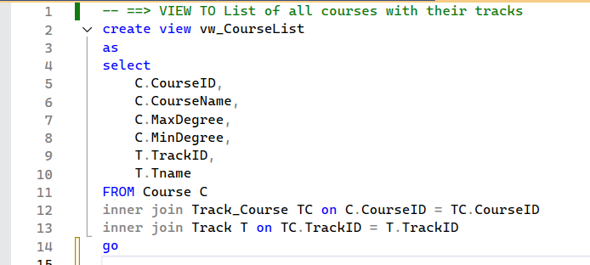
Purpose: The vw_CourseList view provides a consolidated list of all courses available in the system along with the tracks they belong to. Since each course can be associated with one or more tracks through the Track_Course relationship table, this view simplifies the retrieval of course and track details in a single query.
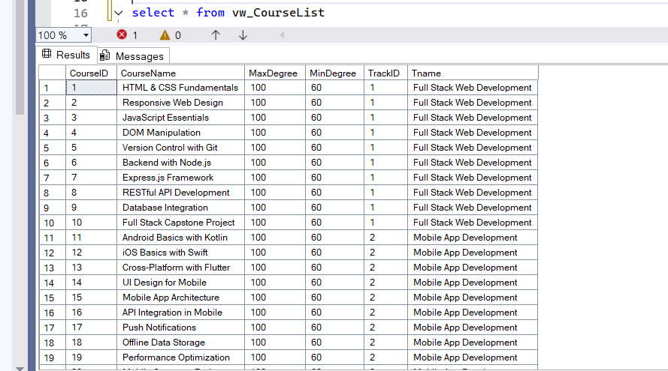
Run query:
View: vw_IntakeTracks
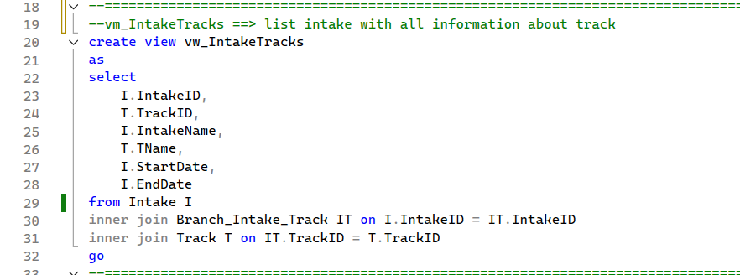
Purpose: The vw_IntakeTracks view provides a combined list of intakes and their associated tracks. Since each intake can offer multiple tracks (and each track can be available in multiple intakes), this view simplifies retrieving all relevant intake and track details in a single query.

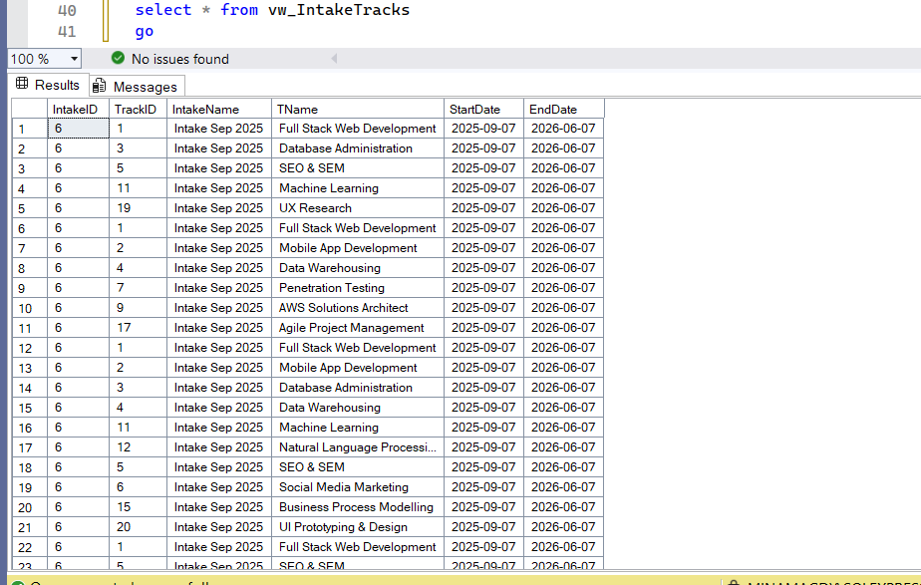
Run query:
View: vw_ExamSchedule
The purpose of the vw_ExamSchedule view is to provide a centralized and simplified way to retrieve information about all upcoming exams in the system. This view helps administrators, instructors, and students by: Listing scheduled exams with their type, degree, duration, and timing.Linking each exam to its course for better context.Displaying the instructor’s details responsible for the exam. Ensuring only future exams are shown (WHERE StartTime > GETDATE()) so users focus on relevant schedules.
Preventing duplicate records through grouping by exam attributes.
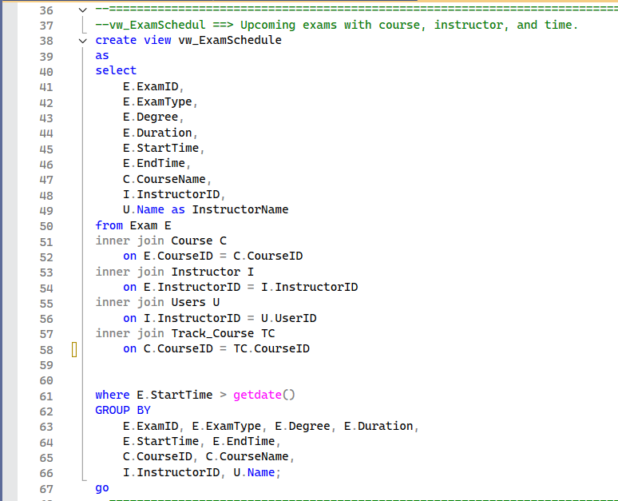
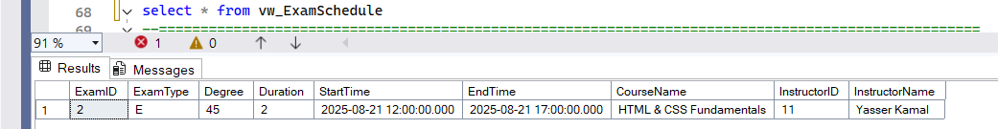
Run query:
View: vw_DepartmentList
The purpose of the vw_DepartmentList view is to provide a consolidated list of all instructors along with their associated department and the courses they teach.This view is especially useful for administrators and department heads who need a clear overview of teaching assignments across departments.
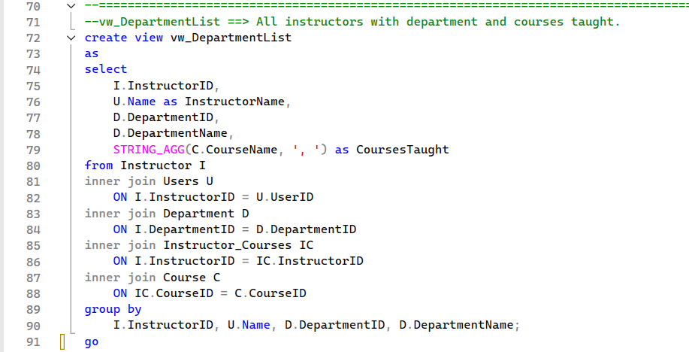
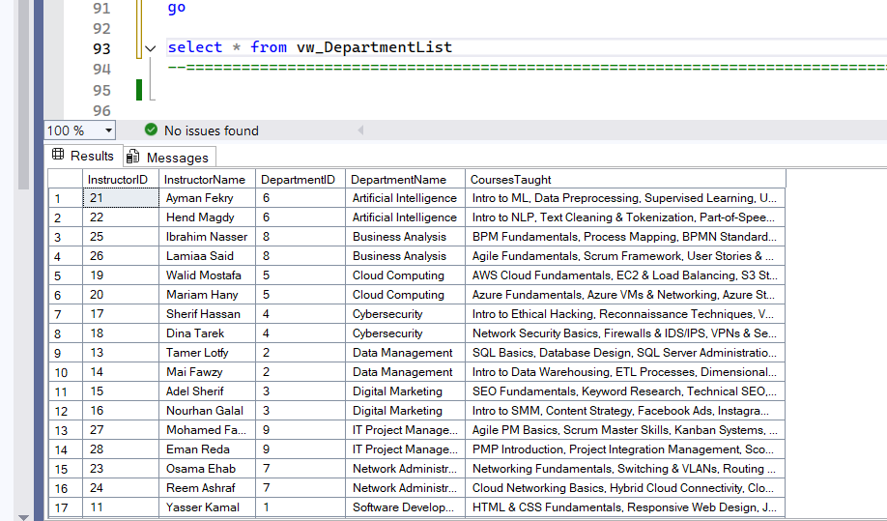
Run Query:
vw_StudentExamTotal
Summarizes the total mark each student scored in a given exam.
It groups by student and exam, summing all question grades.
Used to show the student’s final exam result.
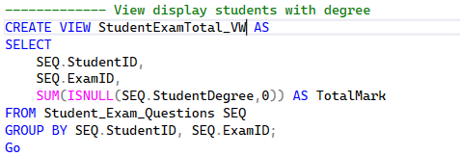

Fuctions
Functions: fn_BranchDetails
Purpose: The function fn_BranchDetails is a table-valued function designed to return comprehensive details about a specific branch when provided with a BranchID. this function accepts a branch identifier as a parameter and dynamically returns all relevant information about that branch, including manager details, intake schedules, and tracks offered.
Key Features:
Branch Information: Displays core branch details such as name, address, and phone number.
Manager Information: Retrieves manager details (ID, name, email, phone) linked to the branch.
Intake Information: Includes intake IDs, names, start dates, and end dates for intakes associated with the branch.
Track Information: Shows the tracks available within the branch’s intakes.
Dynamic Querying: Returns results only for the branch passed into the function.
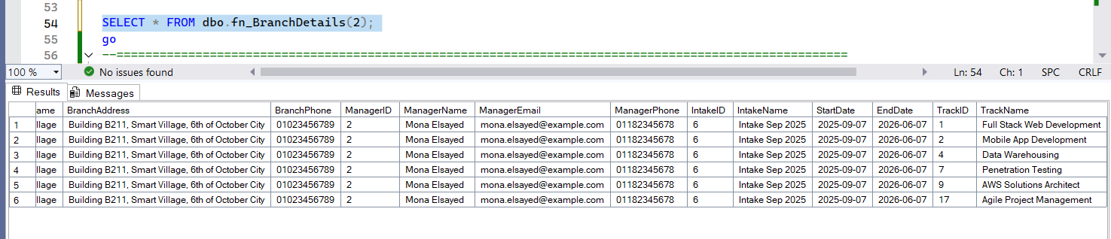
Run Query:

The Query:
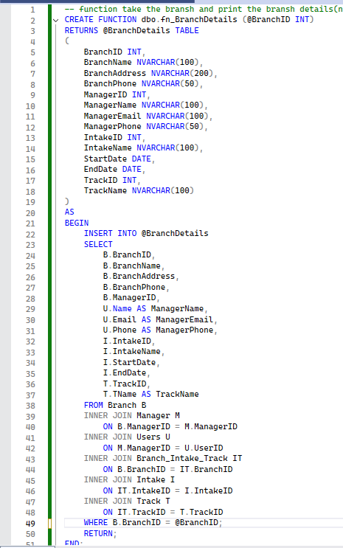

Functions: fn_IntakeTracks
Purpose: The function fn_IntakeTracks is a table-valued function that returns all tracks available in a specific intake within a specific branch. It requires both an IntakeID and a BranchID as input parameters, ensuring the results are scoped to the correct intake–branch combination.
This function provides a flexible, parameter-driven way to retrieve track information compared to static views.
Key Features
Tracks by Intake & Branch: Returns only the tracks offered in the given intake within the specified branch.
Comprehensive Details: Each result row includes TrackID, TrackName, IntakeID, IntakeName, BranchID, and BranchName.
Parameterized Filtering: Ensures the function only retrieves data for the intake and branch provided as input.
Supports multi-branch / multi-intake systems: Useful in cases where the same intake may exist in multiple branches with different tracks.
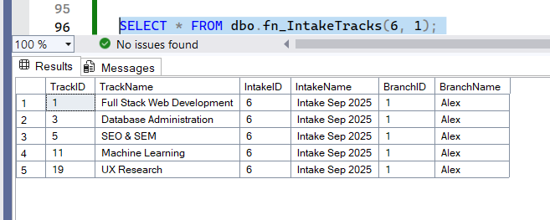
Run Query:

The Query:
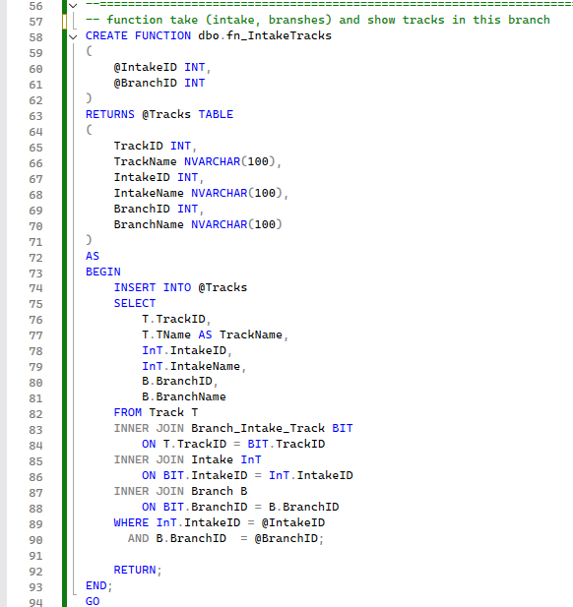

Trigger Name : trg_PreventMultiExamInsert
Table : Student_Exam_Questions
Type : AFTER INSERT
Purpose : Prevent a student from being inserted into more than
one exam at the same time in a single insert operation.
Note : This ensures that one student cannot be registered
in multiple exams in one go.

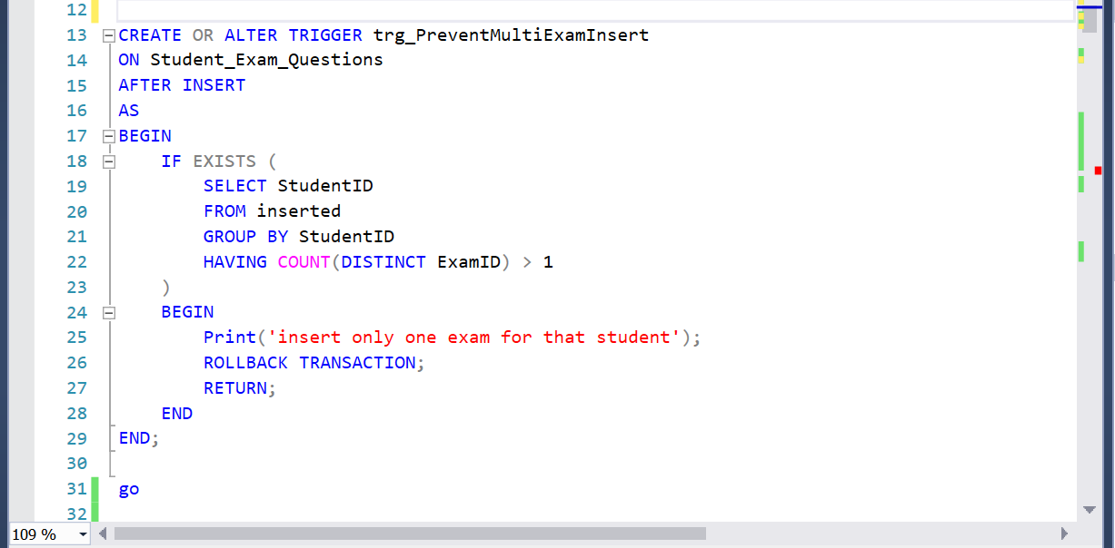

Trigger Name : trg_PreventExamConflict
Table : Student_Exam_Questions
Type : AFTER INSERT
Purpose : Prevent a student from having two exams that overlap
in time (exam schedule conflict).
Logic : Compares new exam's StartTime/EndTime with existing
exams for the same student.

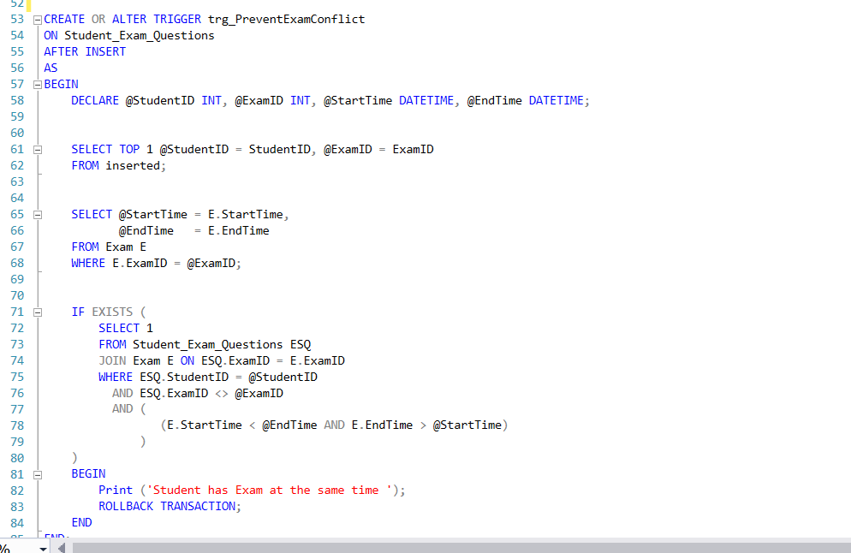

Trigger Name : trg_PreventInvalidExamRetake
Table : Student_Exam_Questions
Type : AFTER INSERT
Purpose : Control exam retake rules:
- A student cannot take the same course's final exam (ExamType = 'E') more than once.

- A student can only take a corrective exam (ExamType = 'C') if they failed the final exam.

- If a student fails a corrective exam, they cannot retake or enter any exam for that course again.
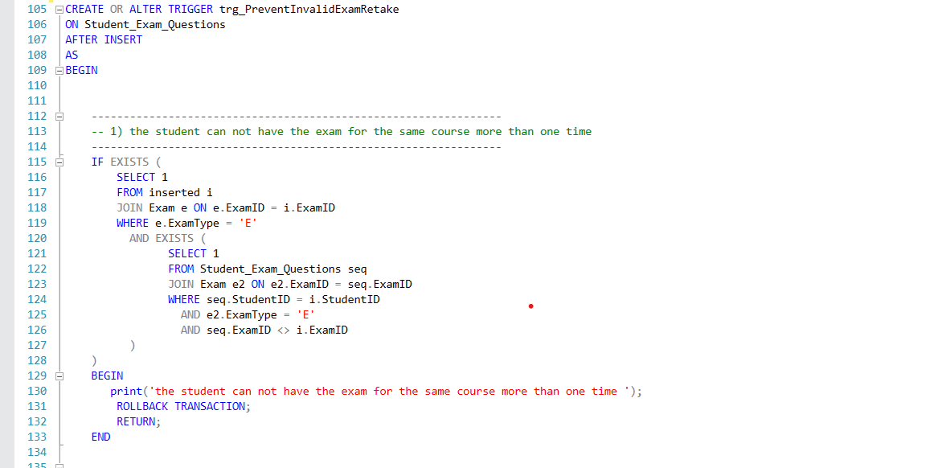

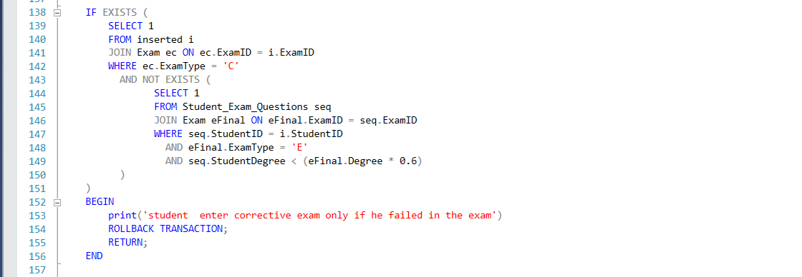

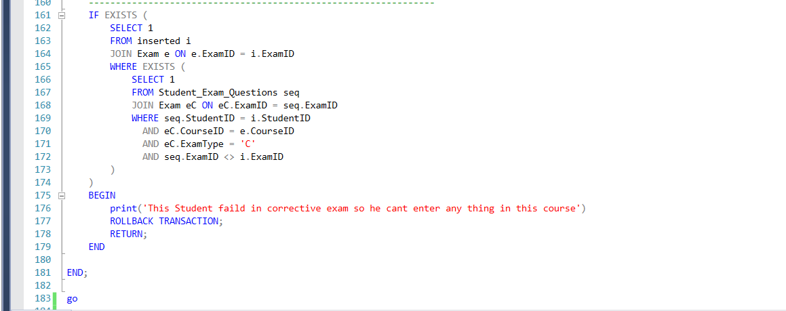

Trigger Name : trg_Check_Exam_Time
Table : Student_Answer
Type : AFTER INSERT
Purpose : Ensure students can only insert answers
during the valid exam Time (StartTime to EndTime).

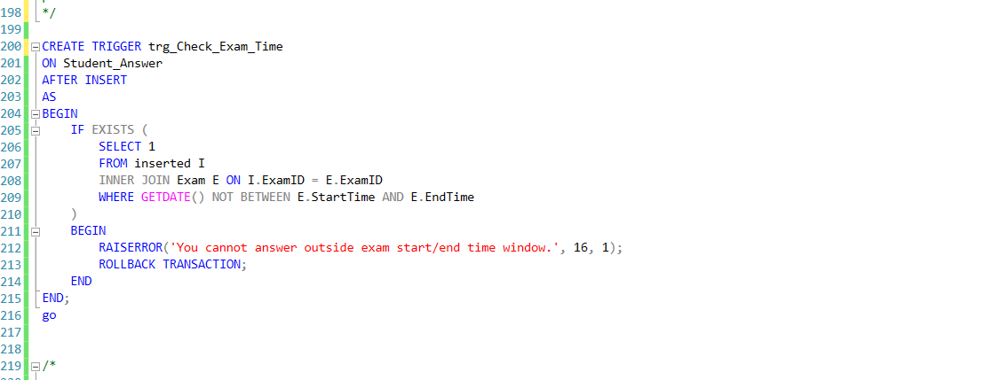

Table : Student_Answer
Type : AFTER INSERT
Purpose : Enforce per-student exam duration.
Logic : Calculate student's first answer time
and disallow answers after (first answer + Duration).

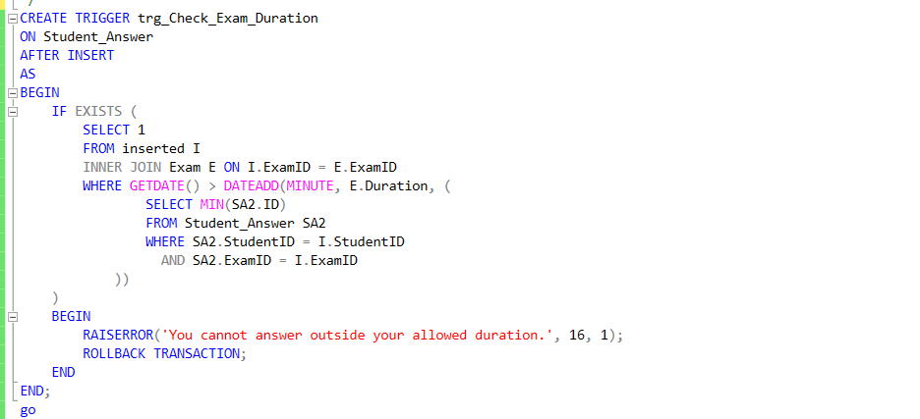

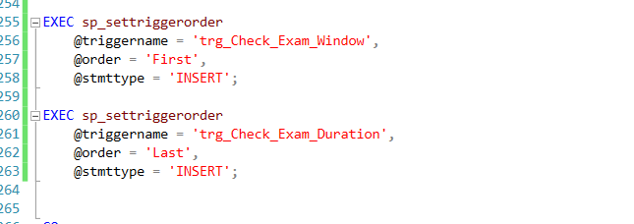

Trigger Name : trg_Audit_Users
Table : Users
Type : AFTER INSERT, UPDATE, DELETE
Purpose : Audit log for all changes in Users table.
Details :
- On INSERT → log new data
- On DELETE → log old data
- On UPDATE → log both old and new data
- Saves username and timestamp

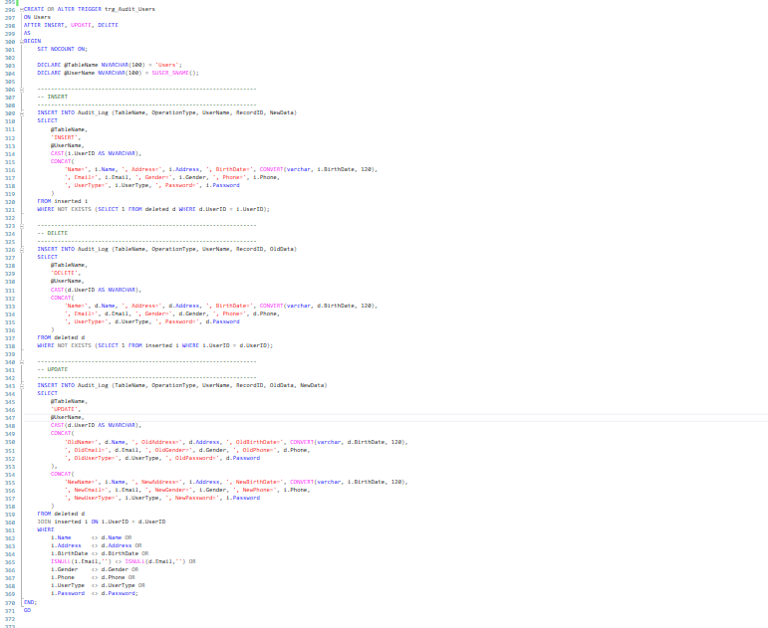

The indexes :
